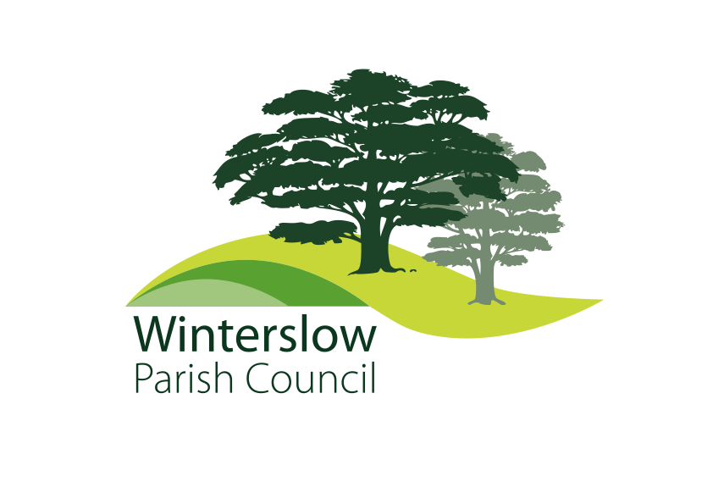

**DATE: 11th September 2024**

**To: All members of Winterslow Parish Council**

# **You are summoned to attend the Extraordinary Meeting of Winterslow Parish Council to be held at Barry’s Field Sports Pavilion on Monday 16th September 2024 at 7.30pm****.**

**For the purpose of transacting the following business;**

**Yours Sincerely**

**Jane Tier**

**Clerk to the Council**

*The Chairman will confirm if all or part of the meeting may be filmed, photographed or audio recorded. If any member of the public has an objection to being filmed or photographed, please would they make themselves known to the Chairman or the Parish Clerk before the start of the meeting*

Prior to the start of the meeting, there will be a public session to enable members of the public to ask questions of and make comment to the Council. Questions not answered at this meeting will be answered in writing to the person asking the question, or may appear as an agenda item for the next appropriate meeting. Members of the public are asked to restrict their comments and/or questions to three minutes.

**AGENDA**

**177.24 To receive apologies.**

**178.24 Declarations of Interest:**

(a) To receive **Declarations of Interest** in respect of matters contained in this agenda

(b).To consider any **Dispensation Requests** received by the Parish Clerk and not previously considered.

**179.24 Primetower**

To Resolve to acknowledge a letter from Primetower (see Appendix A), and to discuss and agree a plan for actions resulting from the letter.

Appendix B is a public notice from the Chairman.

**180.24 To Resolve to agree a plan for Coopting new Parish Councillors at the October meeting.**

**181.24 To confirm the date of the next full council meeting.**

**182.24 To close the meeting.**

**Appendix A**

PRlMETOWER

Winterslow Parish Council by email only c/o Jane Tier

Winterslow Parish Clerk

40 Firs Road

Firsdown

Salisbury

SP5 ISL

1 0 September 2024

Dear Councillors,

# Land off Middleton Road Middle Winterslow

It has been some time since our last communications, and as always, we are keen to engage with the Parish Council at an early stage to establish the current position and circumstances within and around the village, including what WPC expectations are for Winterslow going forward.

To be clear, we are not presenting a development scheme nor a planning application but looking to establish what the PC expectations would be if such an application were to be made at a future date. The NPPF is clear that the best possible economic, social, and environmental outcomes should always be sought, it is this we are following.

By way of example, we have recently become aware of the proposals to create an integrated cycleway network within the village better linking key destinations. Concerns are noted from the presentation regarding potential user conflicts on Middleton Road directly adjoining the site. As you may recall, previous proposals from us incorporated a network of routes that would directly overcome these issues. We also suspect you will wish to discuss school pupil numbers, and other issues that do and/or will affect village life at some point. This is a fact-finding exercise on our part and we believe you are uniquely placed to draw together the wants and needs of the many interested parties.

As a general observation based on past experiences, we appreciate that there will always be local interest in any development proposals for this land and we think it would be helpful for both parties to pull together/understand what it is WPC seek going forward. This dialogue can be commenced via email outlining your position and views, or we are more than happy to meet up and discuss the site if that is a more suitable way to move forward. Experience suggests that a working committee is a more effective method.

We also appreciate that WPC will want to involve the wider village, however at this initial, early stage we do first need an agenda from WPC to work from and we foresee a wider audience some way down the line as proposals evolve.

I look forward to hearing from you.

Primetower Properties Ltd I Park Place 6 North Road Poole Dorset BH 1 4 OLY

t.01202 71557/ f. 0/202 118971 www.primetower.com

Directors: R.J. Harding,J.A.Yeoman, M.P.Jones FCCA. Registered office: as above. Registered number: 2938378

**PRIMETOWER PARISH COUNCIL NOTICE 11.9.24**

The Parish Council has received a letter** from Primetower proposing ‘engagement’ with the Council to discuss what the community would currently seek if there was a new development proposal for the land at Middleton Road.

The letter will be discussed by Councillors at an Extraordinary General Metting of the Council at 7.30 on Monday 16th September at Barry’s Fields.

The Council has a formal policy** governing any such ‘engagement’ with a developer.

**PLEASE NOTE: There is no Planning Application for the Council and parishioners to comment on.** Our current understanding is that, if there is to be an application, it will not be for many months. We will keep you informed.

There is, however, an opportunity to make the developer aware of any changes in the village since the last application that should be considered in any future proposal for the site. We would welcome input from parishioners, organisations, public and private services.

At the time of previous proposals, the Council was able to negotiate changes to the planning application to provide benefits to the community to be delivered IF the application had been approved.

Such benefits included:

* improved separation from Village Hall
* changes to housing numbers, design, types, and layout
  + more Affordable Homes
  + homes designed for the elderly
  + more ‘starter’ homes
* improved car parking
* new footpaths/cycle tracks
* new playground/equipment
* improved protection for Brown’s Copse
* contributions to Village Hall facilities

Mike Taylor

Chair WPC

** Document on the PC website